**FORMAN CHRISTIAN COLLEGE**

**(A CHARTERED UNIVERSITY)**



**Embedded Systems (CSCS 306)**

**FALL-2019**

**LAB-02**

**7 Segment Counter with Push Buttons**

**Group Members:**

* Mohammad Usman 20-10558
* Haris Naseer 20-10612
* Abeer Butt 20-10596

**Introduction:**

The aim of the lab was to test our skills in dealing with 7-segment and pushbuttons. It tested our coding skills, basically our logic in dealing with pushbuttons, in addition to a 7-segment and combining them in the sense of circuitry and coding.

This lab consists of only one LabTask.

**LabTask:** In this LabTask, we had to connect a 7-segment display with Arduino and connected each segment with an Arduino pin through resistors. We also attached 2 pushbuttons to the Arduino. Finally, after completing the whole circuit, we had to write code so that one push button counts up while the other one counts down and we also had to take care of switch debounce through our code.

**Working Code:**

**LabTask:**

// Pin Numbers for segment LEDs

#define A 2

#define B 3

#define C 4

#define D 5

#define E 6

#define F 7

#define G 8

const int segs[7] = {A, B, C, D, E, F, G};

const byte digits[10] = {0b1000000, 0b1111010, 0b0100100, 0b0110000, 0b0011010, 0b0010001, 0b0000001, 0b1111000, 0b0000000, 0b0010000};

bool isButtonPressed = false;

int counter = 0; // counter for the number of button presses

int incState = 0; // current state of the inc. button

int prevIncState = 0; // previous state of the inc. button

int decState = 0; // current state of the dec. button

int prevDecState = 0; // previous state of the dec. button

void setup()

{

// put your setup code here, to run once:

Serial.begin(9600);

// initialize pin modes

for (int i = 0; i < 7; i++)

{

pinMode(segs[i], OUTPUT);

}

showDigit(digits[0]);

pinMode(12, INPUT_PULLUP); // decrement

pinMode(13, INPUT_PULLUP); // increment

}

void loop()

{

incState = digitalRead(13); // read from pin 13

decState = digitalRead(12); // read from pin 12

incButton(); // check conditions for pin 13

decButton(); // check conditions for pin 12

if(isButtonPressed) // if a button is pressed, that means counter must have updated

{

showDigit(digits[counter]); // show counter

isButtonPressed = false;

}

}

// switches on LEDs of 7 segment

void showDigit(byte digit)

{

for (int i = 0; i < 7; i++)

{

int bit = bitRead(digit, i); // read a single bit

digitalWrite(segs[i], bit); // switch on a particular LED of 7 segment

}

}

// checks conditions for increment button

void incButton()

{

// compare the incState to its previous state

if (incState != prevIncState)

{

// if the state has changed, increment the counter

if (incState)

{

isButtonPressed = true;

counter++;

if(counter > 9)

counter = 0;

Serial.println("Increment - on");

}

else

{

Serial.println("Increment - off");

}

// Delay a little bit to avoid bouncing

delay(50);

}

// save the current state as the prev state, for next time through the loop

prevIncState = incState;

}

// checks conditions for decrement button

void decButton()

{

// compare the decState to its previous state

if (decState != prevDecState)

{

// if the state has changed, decrement the counter

if (decState)

{

isButtonPressed = true;

counter--;

if(counter < 0)

counter = 9;

Serial.println("Decrement - on");

}

else

{

Serial.println("Decrement - off");

}

// Delay a little bit to avoid bouncing

delay(50);

}

// save the current state as the prev state, for next time through the loop

prevDecState = decState;

}

**Circuit Diagram:**

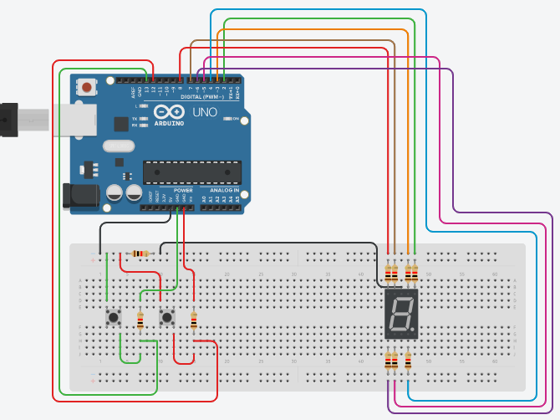

**Running Project Image:**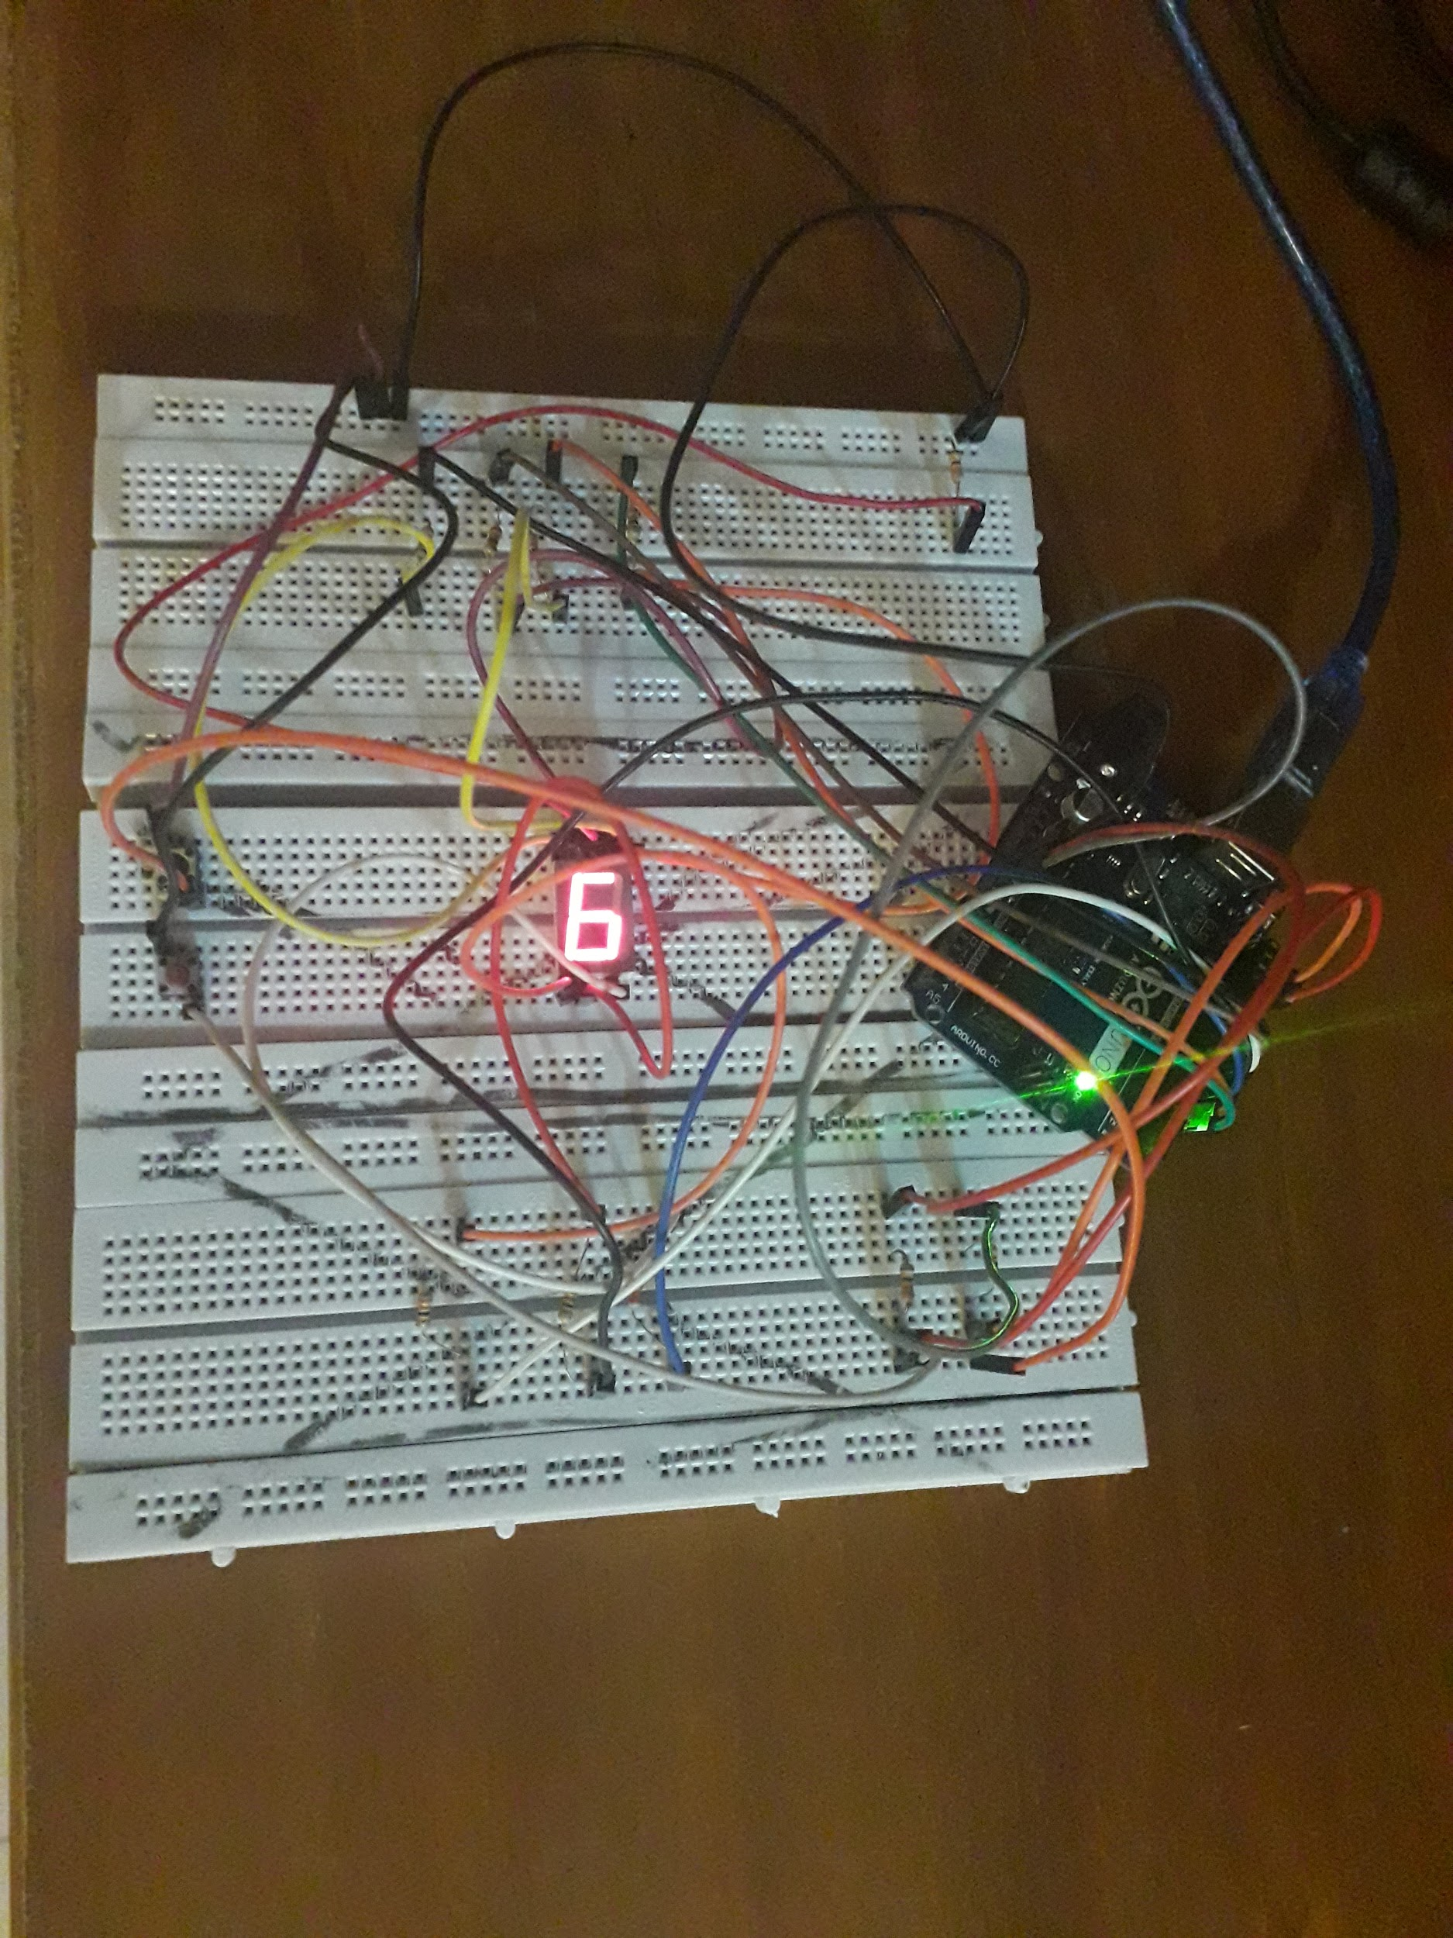

**Running Program Screenshots:**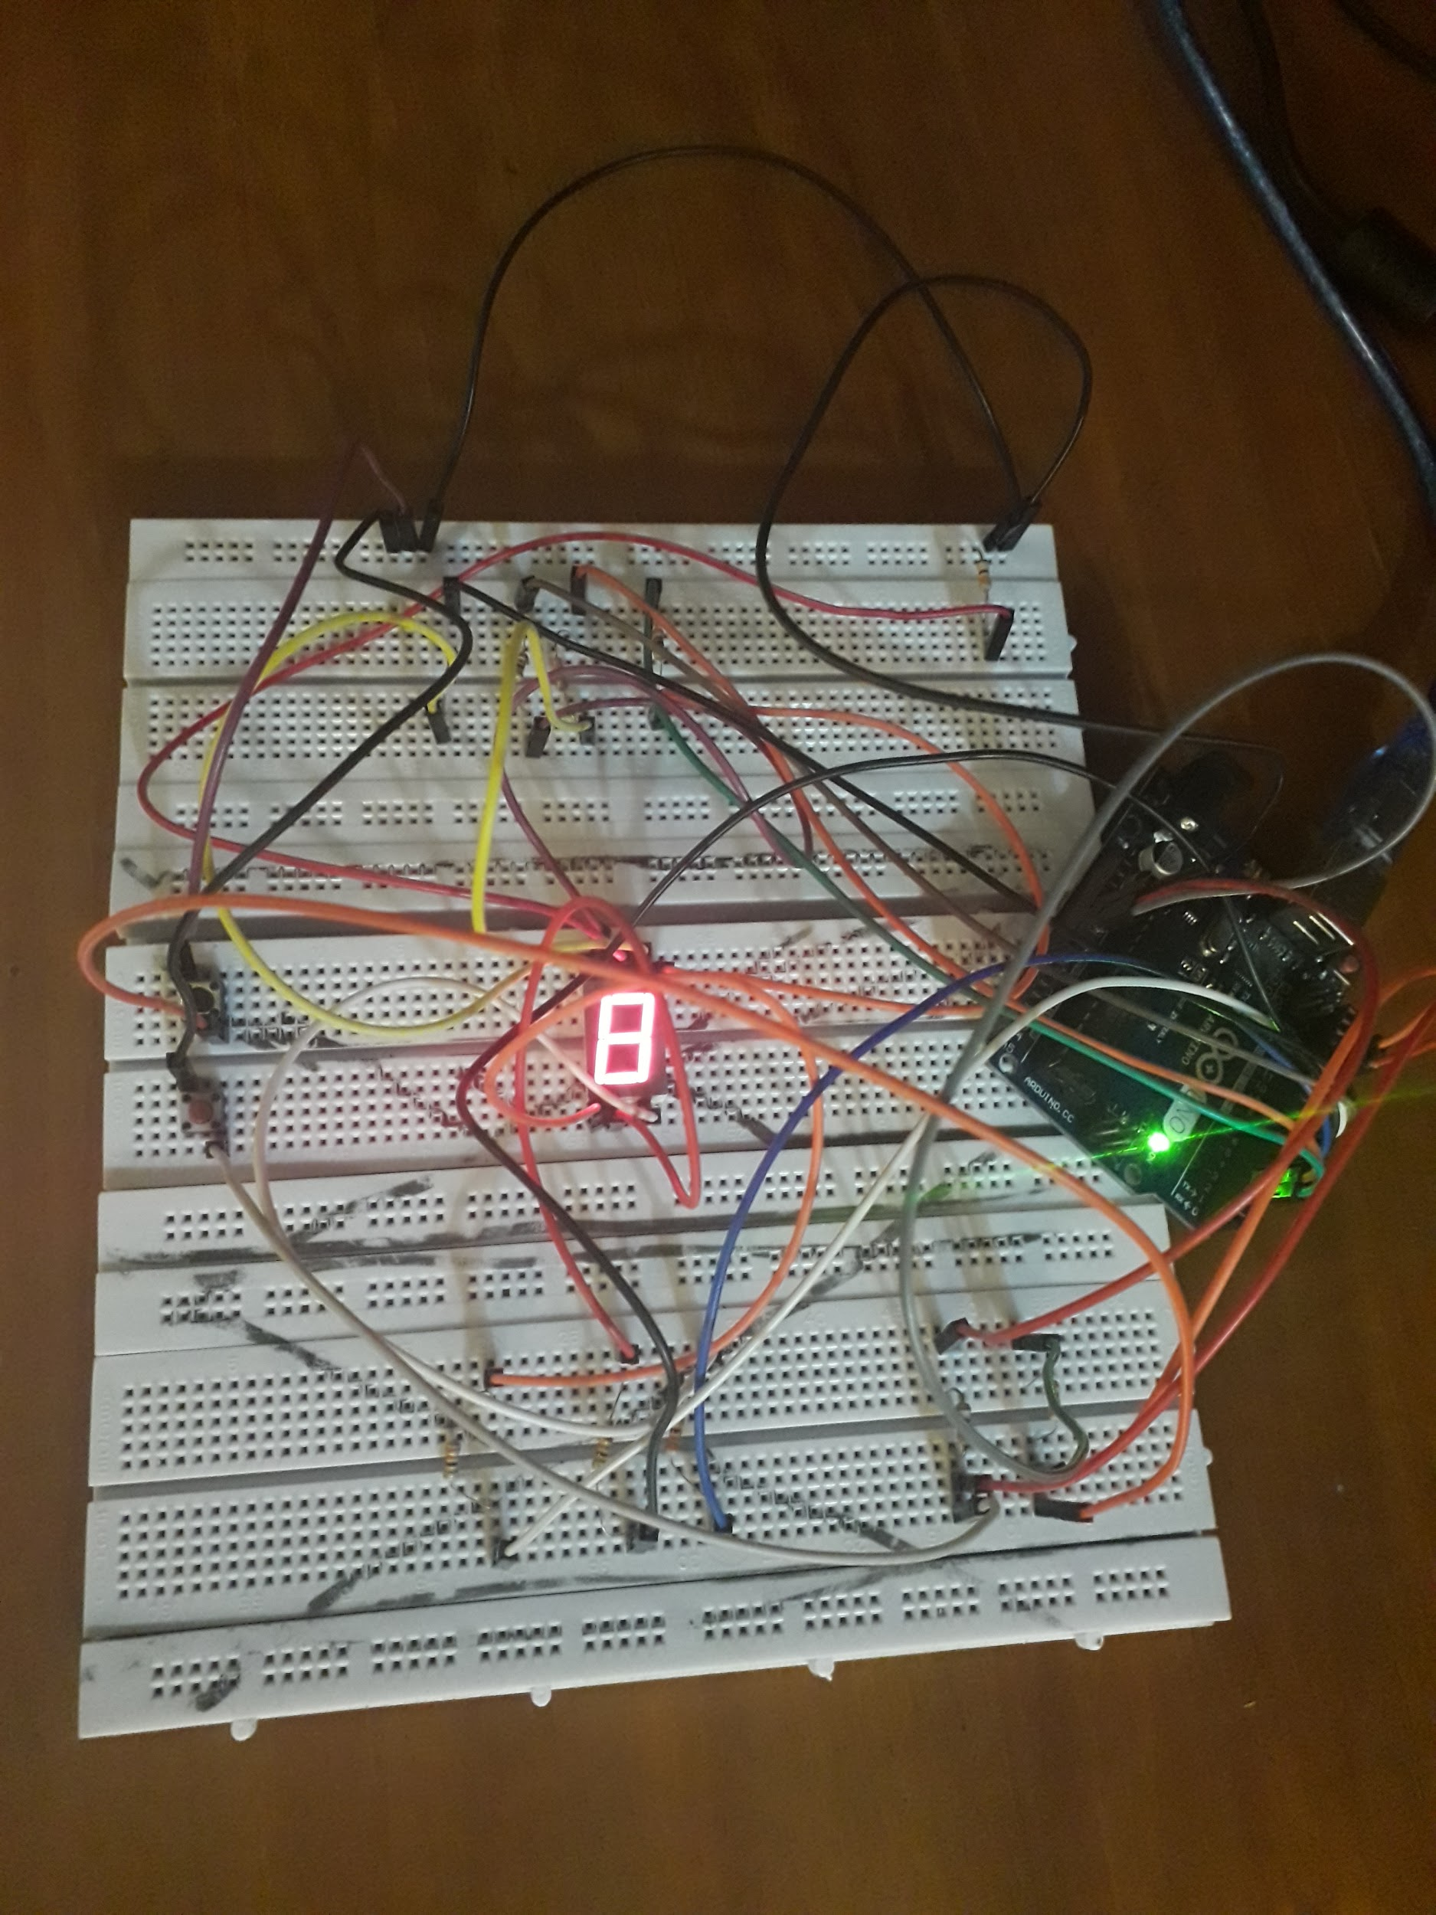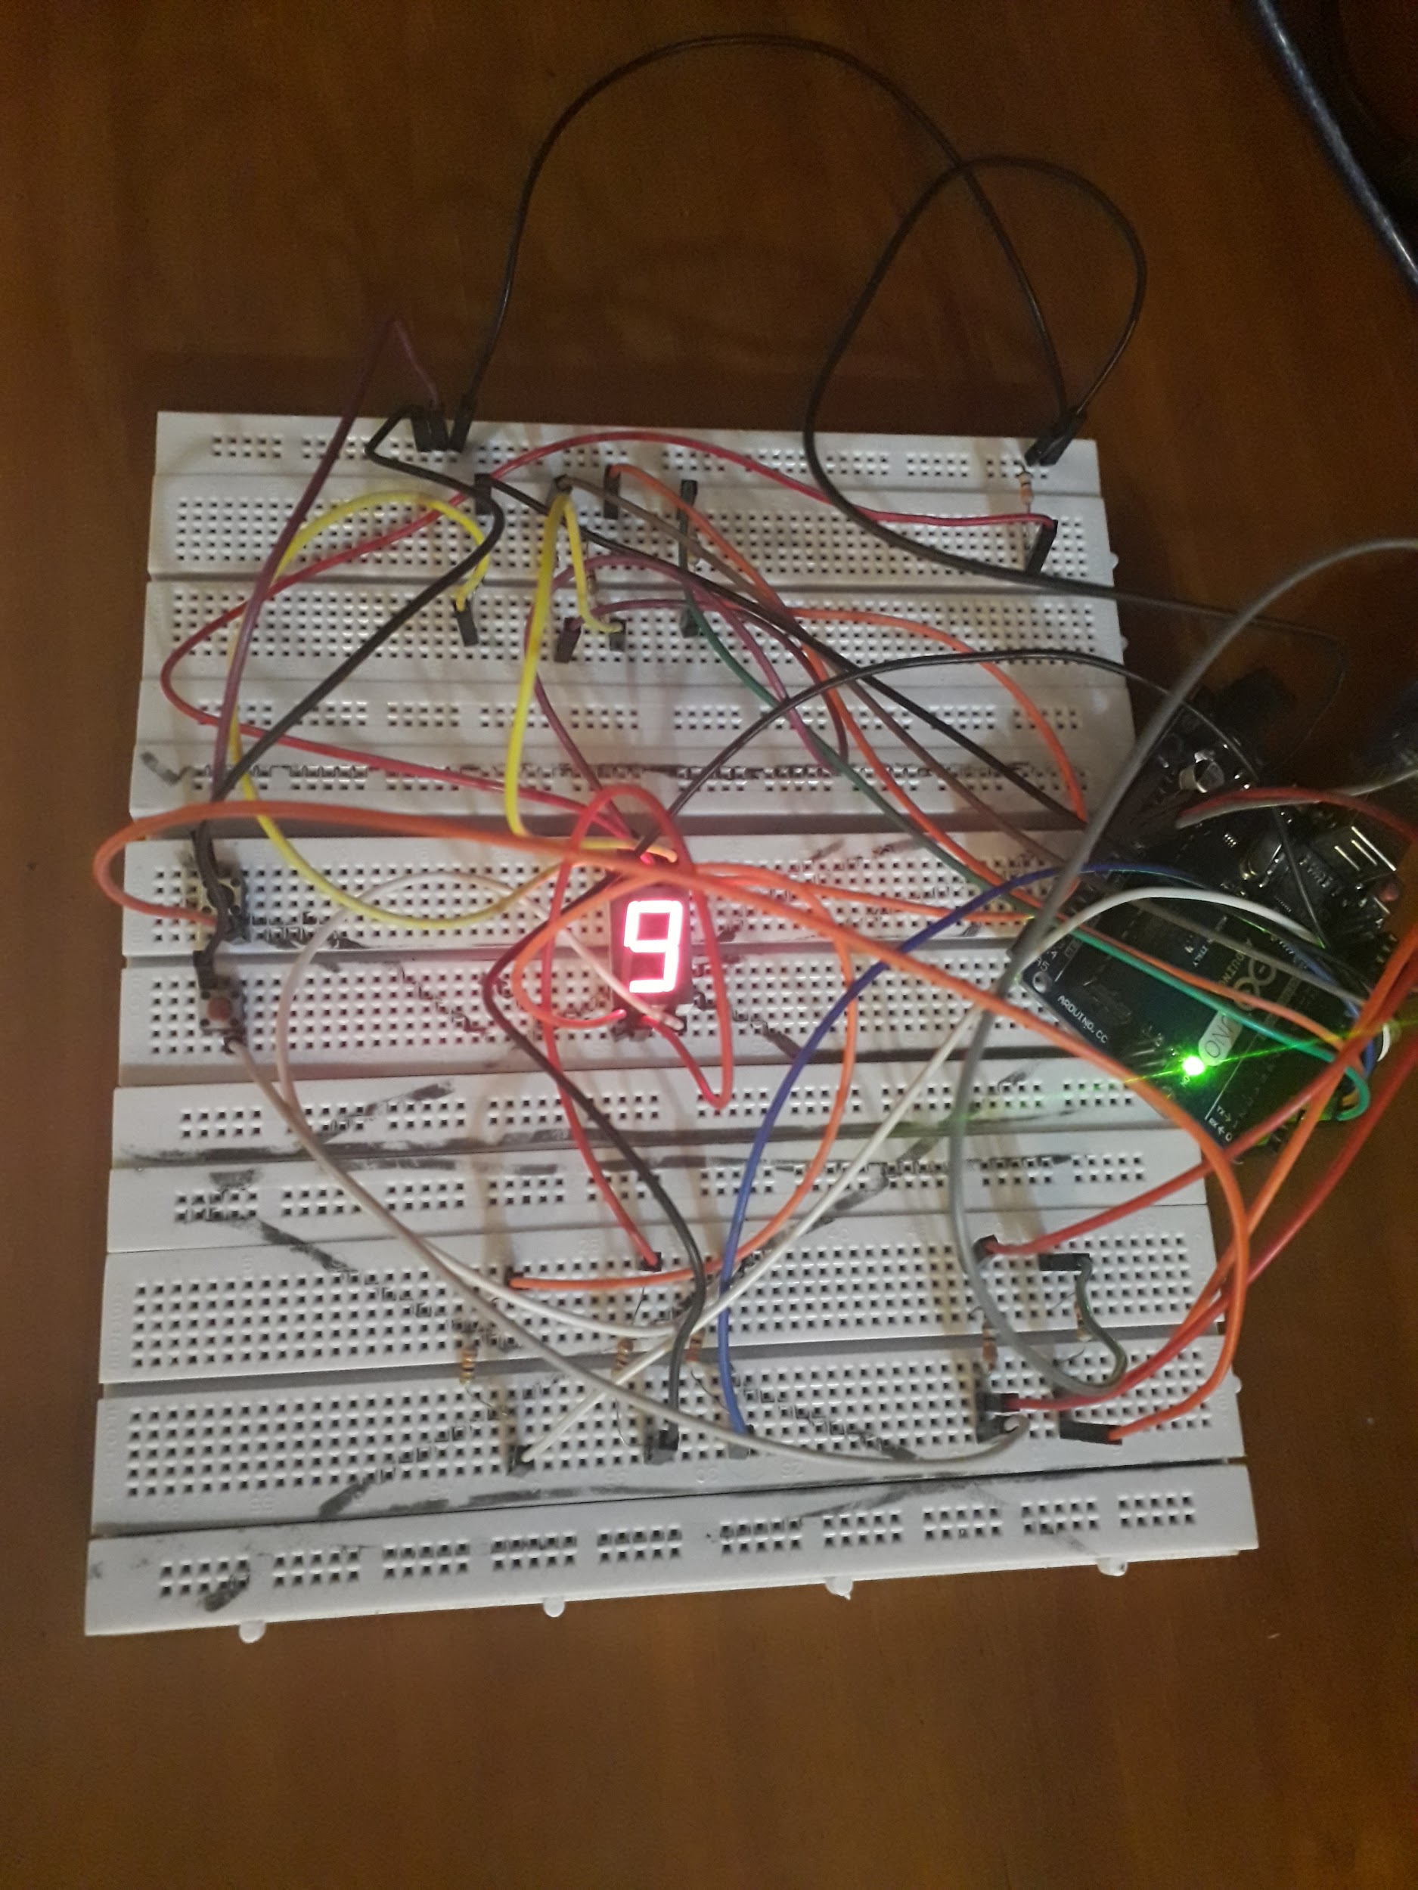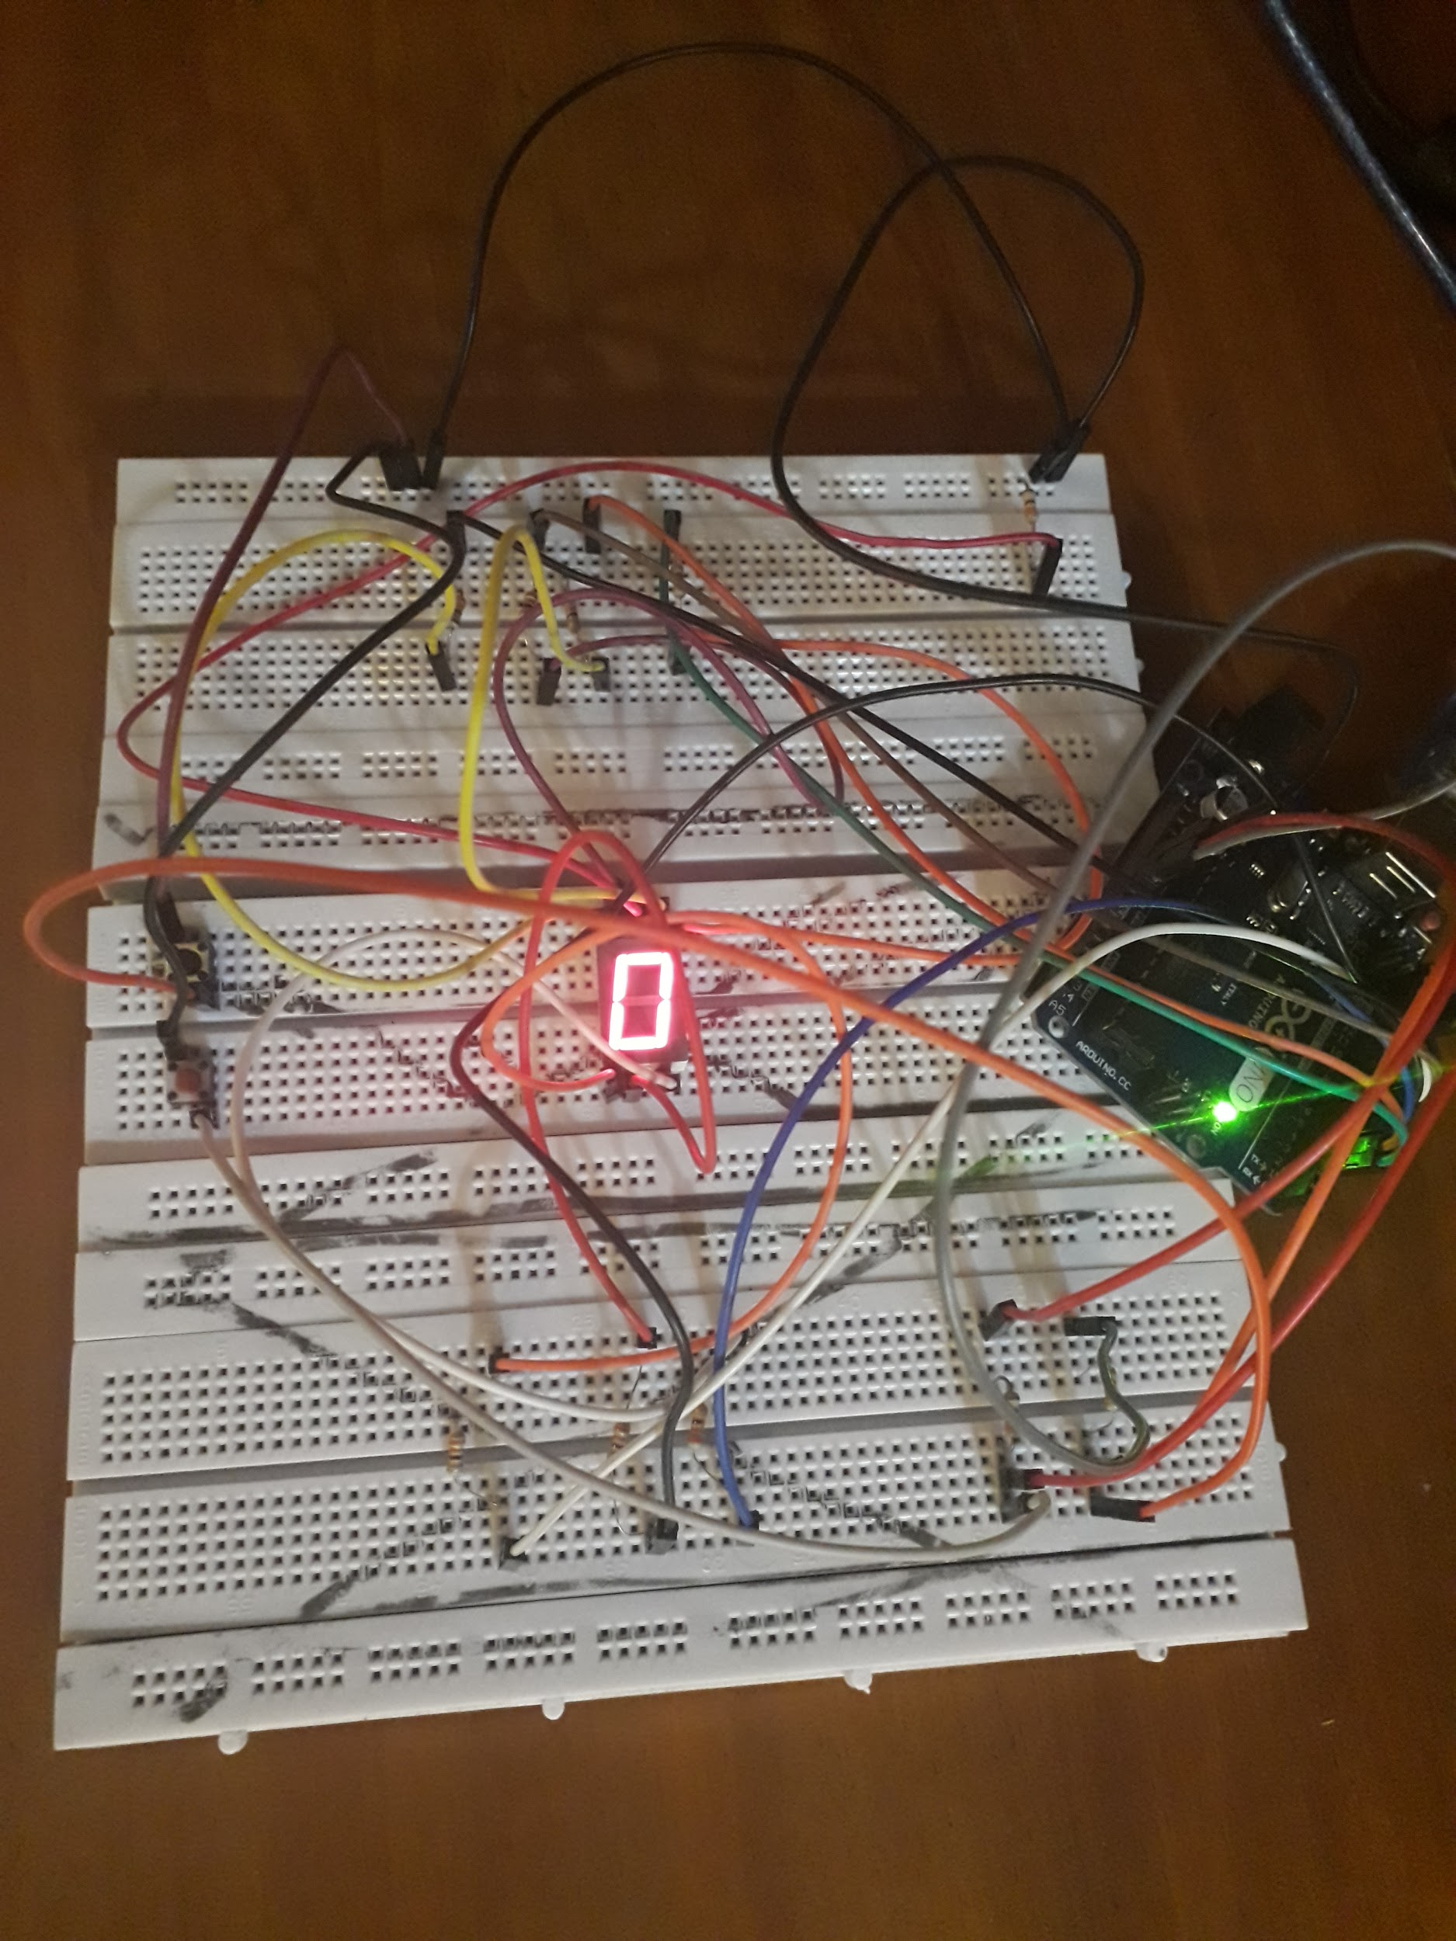

**References:**

* <https://www.arduino.cc/reference/en/language/functions/communication/serial/println/>
* <https://www.arduino.cc/en/tutorial/pushbutton>
* <https://www.allaboutcircuits.com/projects/interface-a-seven-segment-display-to-an-arduino/>
* <https://www.tinkercad.com>